MACH4METAL

Metalworking machinery
Transito 21,
6909 DA BABBERICH
Netherlands
Tel. +31 (0)316 – 247123
Fax. +31 (0)316 - 247956
info@mach4metal.com
www.mach4metal.com

Account No: 66.52.13.883
IBAN : NL33 INGB 0665 2138 83
BIC : INGBNL2A

CNC INNOCENTI X = 16000 Z = 4780
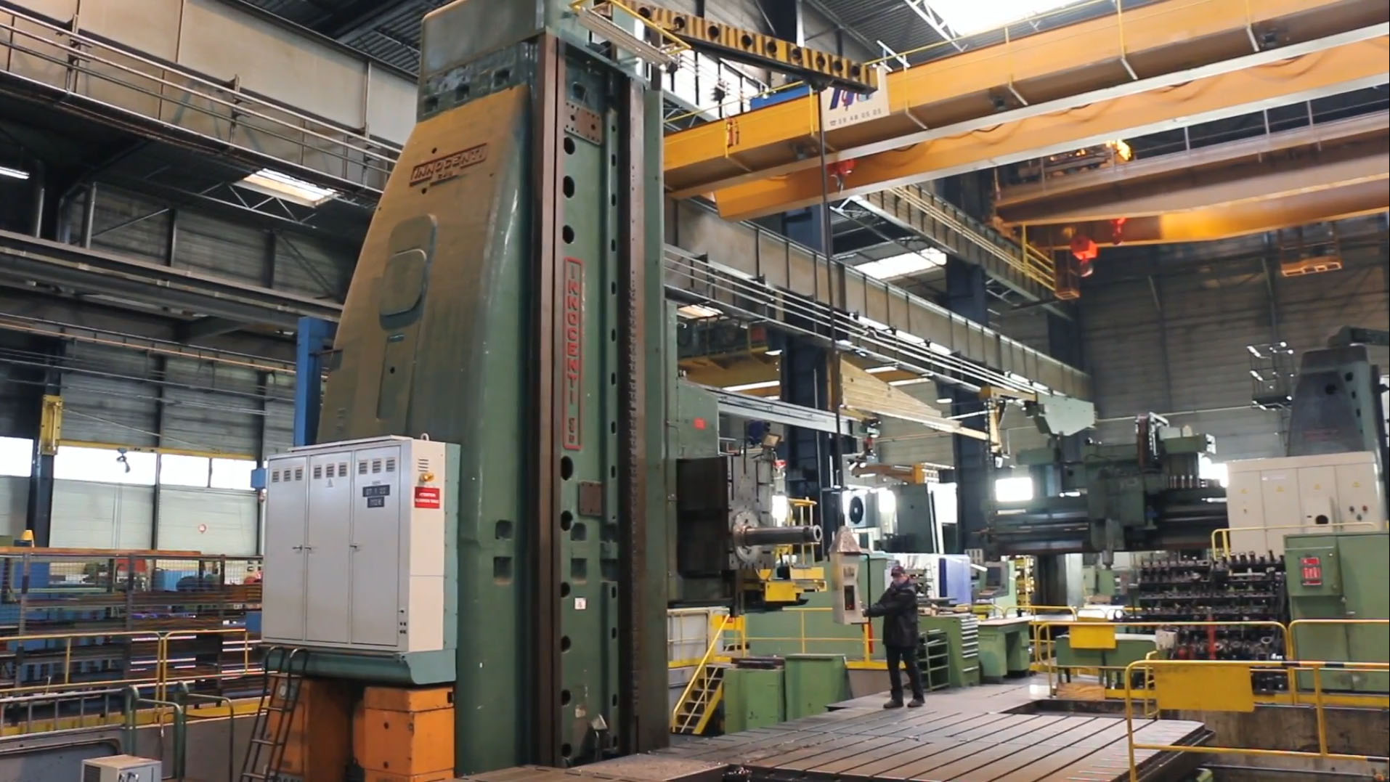
- Make : INNOCENTI
- Typ : FAF 200
- Mach.No :
- Age : Retrofitted 2014

- X – travel : 16.000
- Y – travel : 1.128
- W – travel : 1.600
- Z – travel : 4.785

- Spindle diameter Ø : 200
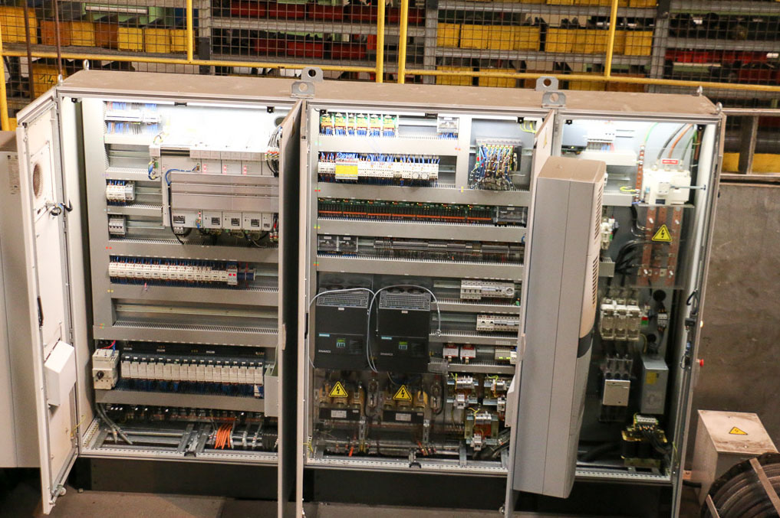
- Ram size : 745 x 915
- Spindle motor : 74 kW
- Spindle taper : SA60

- Spindle turning speed : 500 Rpm
- New 2014 CNC Heidenhain iTNC 530 in 6 Axis
- New 2014 Electric cabinet model “rittal”
- Incl. various milling heads

- Optional PAMA Rotary table
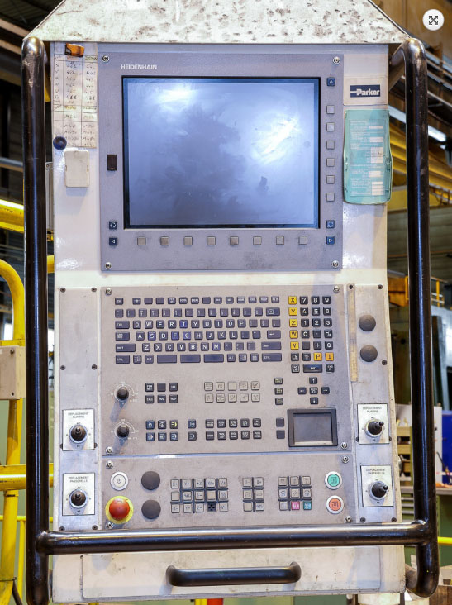
- Size 4250 x 4250 with V-Axis 2590 mm
- Table load 60 / 100 Ton

- Optional INNOCENTI Floorplates
- 15 x 3900 x 1600 x 500 with cross T slot 42
- Weight each plate 5000 Kg
- Field area ca 11700 x 8000 mm

- Dimensions
- Length : 19.000
- Width : 4.385
- Height : 8.035
- Weight : 203.000 Kg

Please Note: The above information has been obtained to the best of our ability and belief from, and from the manufacturers where possible. It is given in good faith, but its accuracy can not be guaranteed. Accordingly, it will not form a representation or constitute contractual terms. We advise you to check any vital details!

